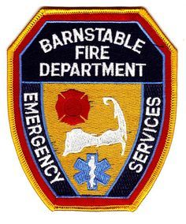
BARNSTABLE FIRE DEPARTMENT

PRESS RELEASE

May 11, 2021 ~ The Barnstable Fire Department, along with the Whale Watcher from Barnstable Harbor, the United States Coast Guard, Mass State Police, and the Barnstable Harbormasters conducted a Maritime Training Exercise. The drill began with a tour of the Whale Watcher to provide familiarity with the layout of the vessel and assist with readiness for potential emergencies. Following the walk through, crews got underway and trained in various maneuvers including coming alongside and boarding the vessel while operating at varying speeds.

The drill concluded with an after-action review, to discuss ways that would improve the efficiency and effectiveness of a response that could have lifesaving potential.

All agencies involved found the training extremely beneficial and would like to thank the Hyannis Whale Watcher Cruises for this unique opportunity.

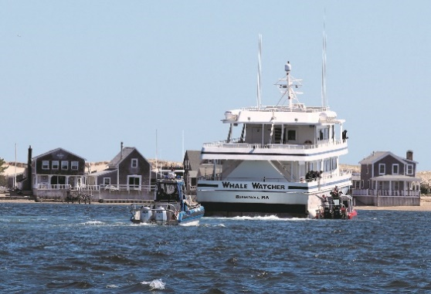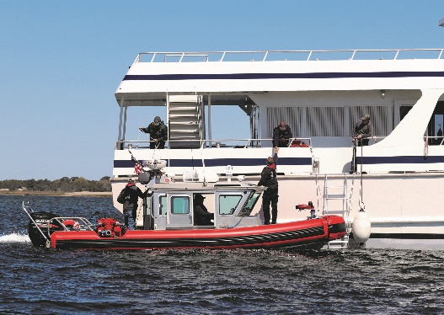

Fire Officer Preparing the Release:
Richard Pfautz – Deputy Fire Chief

Chief of Department- Francis Pulsifer

