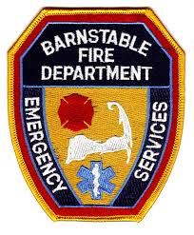
For immediate release:

SENATOR PAUL KIRK TO SPEAK ON 9/11

BARNSTABLE VILLAGE — On Saturday, September 11, 2021 St. Mary’s Episcopal Church, in partnership with the Barnstable Fire Department, will hold its 13th annual ceremony/service of remembrance starting at 9:55 AM at the fire station on Main Street in Barnstable Village.

The ceremony at the fire station will include speaking by Barnstable Fire Department Chief Frank Pulsifer and Barnstable Police Department Chief Matthew Sonnabend. It will also feature the traditional ringing of the bells in honor of the fallen first responders and a duet by Alayna Rooney and Dulce Romilus. Also in attendance will be the BPD Honor Guard and Cub Scouts Honor Guard from Pack 54.

Following a brief ceremony there will be the traditional procession up Main Street led by Dave Knauer on bagpipe to St. Mary’s Church where the 9/11 service will be held in the Old English gardens. This will start at 10:40.

Co-Keynote speakers are Massachusetts Senator Paul Kirk and Reverend/Dr. Libby Gibson-Catania. The theme is “What 9/11/01 taught us about trauma resiliency and the power of community.“

State Representative Tim Whelan will introduce the speakers. Marc Howard is the featured soloist, and the service will also include patriotic music and readings.

A light reception will follow in the gardens.

